# FACCTS – questions

## Case Status

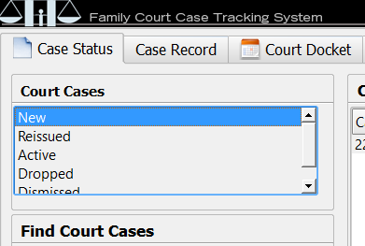

Do you want to choose the single item or multiple ones?

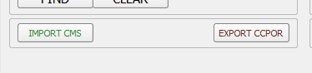

Which workflow is there for “Import CMS” and “Export CCPOR” buttons?

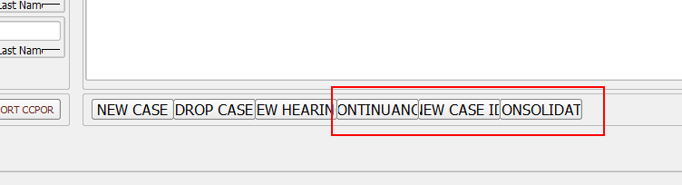

Which workflow/what the program should do if the user press buttons “Continuance”, “New case ID”, “Consolidate”?

## Case record

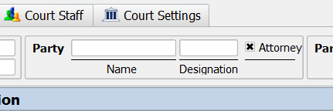

Do you have any rules related to the control “party” above? For example, if the user press “Attorney” does it mean that “Name” and “Designation” fields leave unfilled?

Are there any rules for “Designation” field?

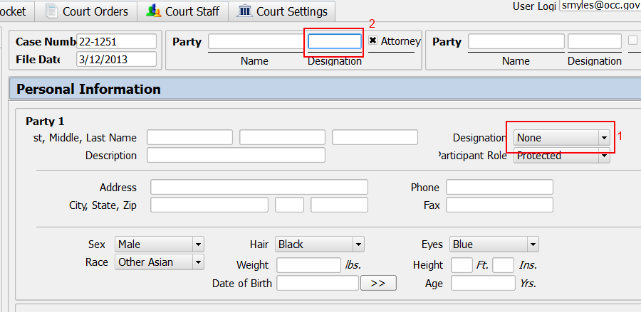

If the field called Designation (1) changed should that change be displayed in the similar field (2) ?

Are there any validation rules for “Phone”, “Fax” or some else text fields?

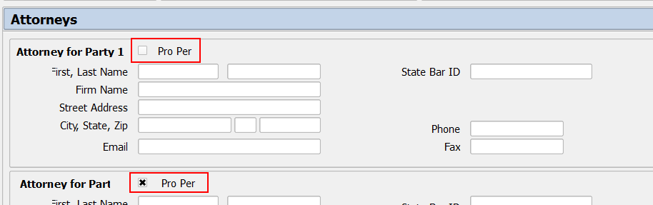

What does mean “Pro Per” checkbox?

Are there any rules for the “Checked/Unchecked” state for that option?